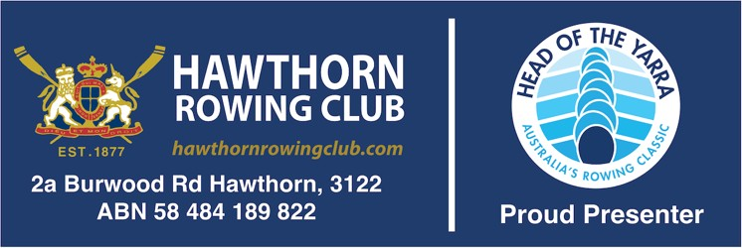

Adult Membership Season 2023/24
(For those with Rowing Experience)

Application process for those with Rowing Experience who wish to join the Hawthorn Rowing Club in Season 2023/24.

As a person with rowing experience, we assume you know how to row, how to handle rowing equipment, are proficient with on-water rowing safety and can easily assimilate into club programs. If that’s you then continue reading. If you have not yet learnt to row, you will need to do a Learn To Row program first before taking out a club membership.

(If you need to do a Learn to Row (LTR) program first, email the Membership Officer Ruth Oliver. LTR programs are run on a regular basis in class sizes of 4 persons to one coach. Ruth compiles a list of enquiries, and then emails those on the list with details of upcoming LTR programs.)

Processing a HRC Adult Membership:

Club Membership Fees are annual season fees, payable in June each year, but revert to half year rate for each season from December 1st for those joining up at the half year.

To process a membership - fill out and return the following to our membership officer Ruth:

  - Membership application form <HERE>. If you know a club member have them nominate you on membership form, otherwise leave nominees blank.
  - A scan of a photo id (Drivers Licence or Passport). This is required for your Insurance registration (covered in Club Fee) via the Rowing Association.
  - Confirmation of payment of Yearly Membership costs ($536 incl. GST - All rowers over the age of 18) to:

Hawthorn Rowing Club Inc. BSB:633 000
Acc: 143 589 471
Description on payment: NewtoHRCYourName

When can you get on the water

The Membership officer will advise you when your RV insurance cover is processed and provisional membership is confirmed. You can then start rowing. All provisional members applications are reviewed and ratified for full membership status as a business item each monthly club committee meeting.

Not ready to join yet?

If you are not yet ready to sign up and join and would like to chat first at the clubhouse to see facilities and speak to someone, the Captain is available at clubhouse most Sunday mornings at 9.30 am after our regular Sunday morning Rowing Development session.

Email the Captain if you would like to pop in on a Sunday morning to look at facilities and discuss membership (as an experienced rower).

About the Club.

Hawthorn Rowing Club is a not-for-profit rowing community. All club officials are volunteers. Coaching services are contracted-in, paid either by members or groups in a crew, or by the club for all-club programs like Rowing Development and Regatta Development.

Our Club runs the largest annual club regatta in the country, the Head of The Yarra . This event funds 60% of the club’s activity and keeps membership fees low. As such, a requirement of membership is member commitment to assist in some way, even if just as a volunteer on the day, in the running of this event.

Fleet & Training

Our Club has a good fleet of all boat classes, including wide hull boats for Learn To Row. Seventy percent of club fleet (Green Equipment) is available to all members to book for usage using our boat bookings system . Thirty percent of fleet is maintained as race fleet and made available with Captain’s permission to those who represent the club at regattas.

All people attending the clubhouse need to book on the Training Register . If you look at this you will get a good idea of the training groups and in particular the 3 times per week Rowing Development Sessions aimed at enabling members interested in regattas, to get some coaching oversight, explore crew options, and find others to row with.

Land Training.

The upstairs floor of the clubhouse houses 12 ergos, spin bikes and gym equipment for member use. Squads do regular gym sessions, and the Captain can let you know when these take place.

Club Access.

After a month or two, when club committee members have had an opportunity to observe a new member’s water safety and equipment handling, they can apply for a club key fob by sending a request to the club secretary. They can then come and go as they please accessing all the club facilities afforded by membership.

Coaching.

Club members who wish to row for Hawthorn in competitions can turn up at any of 3 weekly rowing development sessions where a club funded coach and the club captain will arrange attendees into crews and facilitate connections with like members to develop squads and crews to race and represent the club.

The club also has a register of coaches who can be contracted by members or crews for additional coaching. This contract coaching is a private arrangement between the member and contract coach.

Many social rowers may also take advantage of contract coaching to assist them to gain proficiency and develop regular rowing training with other social members who may not wish to enter rowing competitions.

